Young, Geoff
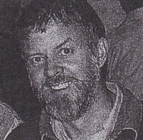
Graduated from Dwellingup cadet school in 1972. Assistant Forester in Manjimup in late 1980s. Promoted to District Forester at Walpole in 1988. In Kalgoorlie 1990s, promoted to Senior Forester in 1991. Transferred to Kimberley Region (Kununurra) in 2000. Senior Operations Officer, Kununurra 2001.

